

XE2 Technical User Guide
(Used in the Beta x86 Product Range)

Document Reference: User Guide
Document Issue: 0.1

Blue Chip Technology Limited
Chowley Oak,
Tattenhall,
Chester.
Cheshire
England
CH3 9EX

Telephone: 44 (0)1829 772000
Website: https://bluechiptechnology.com/

Contents
Copyright 4
Limitations of Liability 4
Trademarks 4
Regulatory Statements 5
Safety Warning for North America 5
Technical User Guide Structure 6
Introduction 7
Functional Overview 8
Power Supply 9
Serial Ports 9
Touch Screen Support 10
Connectors 10
Board Layout 11
Expansion Connector 12
Standard Connector PCBs 14
2-Part Screw Terminal 14
Molex Picoblade 15
USB2.0 4 Port Hub 17
RS422 & RS485 Operation 18
BIOS 19
Secure Boot 19
Boot Order 20
BIOS Firmware upgrade via OTA 20
General Precautions 23
Electro-Static Discharges 23
Electromagnetic Compatibility 23
On-Board Battery 24
On-Board EMMC 24
Windows 11 IOT Enterprise LTSC 25
Peripherals 26
Contact Details 29
Amendment History 29

Copyright
All rights reserved. No part of this publication may be reproduced, stored in any retrieval system, or transmitted, in any form or by any means, electronic, mechanical, photocopied, recorded or otherwise, without the prior permission, in writing, from the publisher. For permission in the UK please contact Blue Chip Technology.
Information offered in this manual is believed to be correct at the time of printing. Blue Chip Technology accepts no responsibility for any inaccuracies. The information contained herein is subject to change without notice. There are no express or implied licences granted herein to any intellectual property rights of Blue Chip Technology Ltd.

Limitations of Liability
In no event shall Blue Chip Technology be held liable for any loss, expenses or damages of any kind whatsoever, whether direct, indirect, incidental or consequential, arising from the design or use of this product or the support materials supplied with this product. If this product proves to be defective, Blue Chip Technology is only obliged to replace or refund the purchase price at Blue Chip Technology's discretion according to their Terms and Conditions of Sale.

Trademarks
Intel® is the registered trademark of Intel Corporation in the U.S. and other countries.
Linux® is the registered trademark of Linus Torvalds in the U.S. and other countries.
Windows® is the registered trademark of Microsoft Corporation in the United States and/or other countries., Inc. 2007

Regulatory Statements
CE
This product has been designed and assessed to meet the essential protection requirements of the European EMC Directive (2014/30/EU), the Low Voltage Directive (2014/35/EU), and the RoHS Directive (2011/65/EU) when installed and used in conjunction with the guidelines provided within this document.
FCC
FCC compliance of product versions equipped with radio frequency interfaces may require specific approval for the finished products.
WARNING
Changes or modifications not expressly approved by the manufacturer could void the user's authority to operate the equipment.

Safety Warning for North America
If the power lead (cord) is not supplied with the computer, select a power lead according to your local electrical regulations. In the USA use a 'UL listed' lead. In Canada use a CSA approved or 'cUL listed' lead.
Si le cordon secteur n'est pas livré avec l'ordinateur, utiliser un cordon secteur en accord avec votre code electrique nationale. En l'Etat Unis utiliser un cordon secteur 'UL listed'. En Canada utiliser un cordon secteur certifié CSA, ou 'cUL listed'.

Technical User Guide Structure
This manual describes in detail the XE2 host board for use with the Beta range of products.
In this document we have tried to include as much information as possible, but we have not duplicated information that is provided in other XE2 documents or standard Technical References, unless it proved to be necessary to aid in the understanding of the product.
The manual is sectioned as follows:
- Introduction.
- Hardware interfaces & connectors.
- Layout, showing where the various connectors are located, and their pin-out details.
- Overviews, showing outline dimensions and installation tips.
- Maintenance details.
- Operating Systems.
We strongly recommend that you study this manual carefully before attempting to interface with the XE2 or change the standard configurations. Whilst all the necessary information is available in this manual, we would recommend that unless you are confident, you contact your supplier for guidance.
IT IS PARTICULARLY IMPORTANT THAT YOU READ THE ESD SECTION BEFORE HANDLING ANY COMPONENTS INSIDE THE UNIT.
If you have any suggestions or find any errors concerning this manual and want to inform us of these, please contact our Technical Services department with the relevant details at:
https://bluechiptechnology.com/support/online-helpdesk/

Introduction
The Blue Chip Technology XE2 Host Board is designed to support our Beta range of products and function as a standalone SBC.
The Beta LCD range includes screen sizes of 7.1" (800*480), 9.7" (1024*768) and 12.1” (1280*800) together with either resistive or projected capacitance touch screens up to much larger displays either through the LVDS or HDMI interfaces. For the Beta products there is a front panel/bezel available, for further details please see our Beta range of products. If you do not require a touch screen, then we recommend that you choose the resistive touch screen version if you require the lowest cost. Alternatively, if you require the most resilient screen, we recommend the projected capacitance version which has a glass top surface.
The XE2 Host Board supports several interfaces:
Standard connectivity includes:
- 10/100/1000/2500 LAN
- USB 3.0 Hosts
- USB 2.0 Hosts
- 2x RS232
- 1x RS422/485
- Stereo Audio (input/output)
- General Purpose IO signals
- Real Time Clock 3x M.2 sockets.
The M.2 sockets can be utilised for additional SSDs, Wifi, Bluetooth, 3G/4G, GPS and LANs. The XE2 also provides for a Lithium Battery (via two pin connector) to keep the Real Time Clock alive, retain time and data when the unit is powered off.
The mechanical options include open frame operation to allow integration into customers own mechanical assembly or with an optional rear cover to allow it to be used as a standalone device. Mounting Kits are also available and include VESA mount, panel mount, etc.
Operating Systems supported include Windows 11 IOT Enterprise LTSC and Linux. However, as the XE2 is a modern standard x86 platform a wide variety of operating systems can be supported. If you require support for any other operating, please contact your salesperson.
NOTE: For the panel mount option, please ensure that the thickness of the panel is sufficient to prevent deforming of the panel when the unit is attached, or fit strengthening bars to prevent deforming.

Functional Overview
The XE2 is a unique x86/PC platform produced by Blue Chip Technology to be used as the SBC for the Beta range of products and for standalone use.
The XE2 features include:
- Quad Core Intel N150 CPU with 6MB Intel Smart cache
- Intel Graphics.
- Support for up to two independent displays (HDMI 2.1 & LVDS)
- Multi format encode and decode support
- Support for DirectX® 12.1, OpenGL 4.6, OpenCL 3.0
- High performance, integrated Controller Hub
- 8GB or 16GB memory options
- LAN 10/100/1000/2500Mbit
- M.2 connectors with B, E and M keys.
- 2x USB Host 3.0
- 3x USB Host 2.0 (one presented on P15)
- 12 off General purpose Input / Outputs
- Low power consumption
- Single RS232 (presented on P15)
- Single RS232/422/485 - configured at factory (presented on P15)
- Debug RS232 (presented on P15 and P17)
- SMBus
- Stereo Audio inputs and outputs
- Mono Audio Amplifier
- Battery backed Real Time Clock
- Custom Splash Screen option
- Extended Temperature range
- Power Button & Reset support
Beta Display Options
- 7.1” 1280*800 resolution
- 9.7" 1024*768 resolution
- 12.1” 1280*800 resolution
Beta Touch Screen Options – capacitive or resistive configured at factory
- 7.1” resistive
- 7.1” projected capacitive
- 9.7” resistive
- 9.7” projected capacitive
- 12.1” resistive
- 12.1” projected capacitive

Power Supply
Please read this
(even if you do not read any other part of this manual)
The XE2 Touch Computer requires an external DC power supply between 12v and 24v. The absolute maximum voltage before XE2 is permanently damaged is 30 volts.
Power can be applied through the following connectors:
- Jack plug (2.5mm centre diameter which is the positive contact) with a 5.5mm overall diameter. See below:
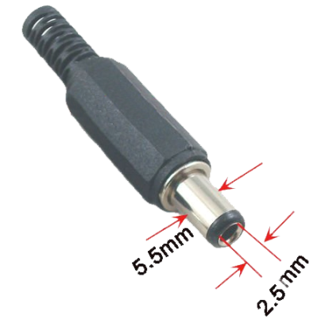
- Screw terminal connector when ordered instead of the Jack connector
- If the Screw terminal PCB (as opposed to the screw terminal connector in 2 above) is fitted, then power can be applied through pins a (positive) and b (negative). Please note that these are lower case letters and not A and B.

Serial Ports
Your XE2 has three asynchronous serial ports.
Ports 1, and 2 fixed as RS232 ports and are TX + RX only (i.e. no hardware handshaking – which is not an issue these days as the XE2 is fast enough to cope with most baud rates).
Ports 1 and 2 are exposed on the 50-way expansion header (P15) and are designed for connection to external hardware. Note that Port 1 is also available on the P17 (Picoblade connector).
Port 3 is also exposed on the 50way expansion header (P15), but it is different in that it is factory configured to operate as an RS422/RS485 port. This can be configured at the factory as another RS232 port if required. If you would like to change it to RS232 please contact your Blue Chip Technology sales person.
We supply cable sets for the serial ports (and other interfaces) so if you want to buy them just contact your sales contact.

Touch Screen Support
The XE2 can support both Resistive and Projected Capacitance touch screens.

Connectors
The XE2 has the following industry standard connectors:

Ethernet
RJ45 – 10/100/1000/2500 Mbit
LEDs – show connection speed and activity

USB Host 3.0
Type A Connector - Blue inner

USB Host 2.0
Type A Connector - White inner

RTC Battery
The RTC Battery and Speaker connectors are not industry standard, and the details are as follows:
Connector P16 – Real Time Clock Battery
Pin | Signal | Comments | Voltage
1 | Battery Positive | CR2032 or equivalent | Nominal 3.6 volts
2 | Battery Negative | CR2032 or equivalent | 0 volts
Important: For correct operation it is mandatory that XE2 is fitted with a real-time clock battery.

Speaker
Connector P14 – Audio Amplifier Output to Speaker (parallel connection on P15)
Pin | Signal | Comments
1 | Speaker Positive | Speaker load to be no lower than 4 ohms with 2.5 watts handling
2 | Speaker Negative | Speaker load to be no lower than 4 ohms with 2.5 watts handling

Board Layout
The connectors and key devices mounted on the top of the XE2 are:
Cap Touch/Res Touch SIM LVDS LCD 9.7” LVDS LCD 7”/12”
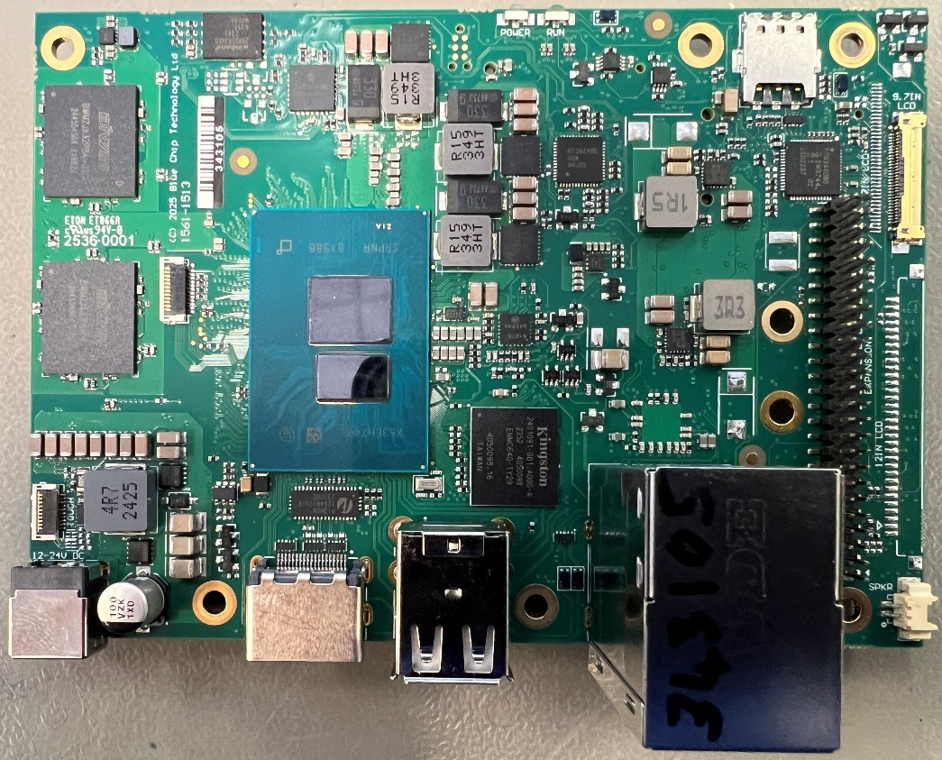
Power HDMI 2xUSB2.0 Ethernet/2xUSB3.0 Speaker Expansion Conn.
The connectors and key devices mounted on the bottom of the XE2 are:
Fan
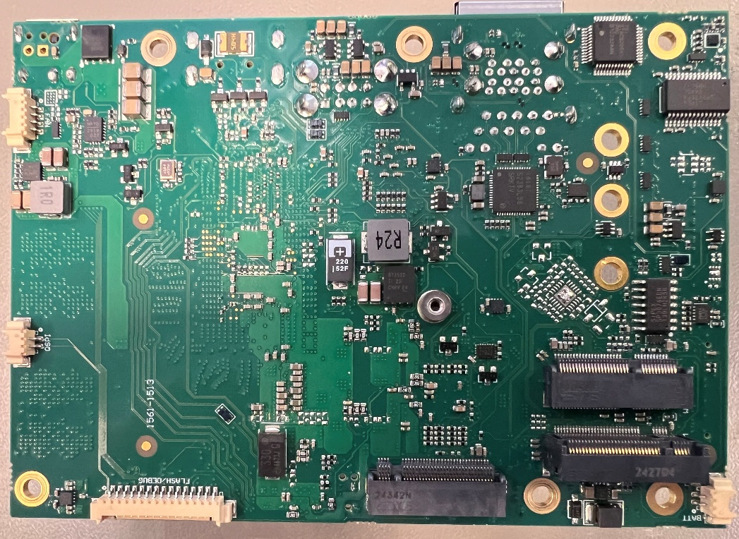
Port1 M.2 Connectors RTC Battery

Expansion Connector
The XE2 is offered with three standard connector board options which are detailed in the section entitled “Standard Connector PCBs”. If you would like to design your own connector PCB for your new product then we are happy to supply XE2 units without a Connector PCB fitted. If you would like us to design the connector PCB (with or without additional electronics) just contact us.
Please note that the speaker fitted on the XE2 PCB (as shown above) is in parallel with the speaker connections on the Connector PCB. If you connect two low impedance speakers up in parallel, then the audio amplifier will probably sense the low impedance and shut down. The XE2 will need to be powered off for a few seconds, one of the speakers removed and then powered on again to re-activate the audio amplifier.
If you would like to design your own Connector PCB you will need the pin out of the 50-way connector (P15) on our XE2 which provides the connector interface and therefore pin out which is as follows:

Pin | Signal | Comment | Pin | Signal | Comment
1 | 0 volts |  | 2 | 0 volts
3 | GPIO 12 | GPIO signal - 3.3 Volt | 4 | LINEOUT_R | Audio line out – right channel
5 | GPIO 11 | GPIO signal - 3.3 Volt | 6 | LINEOUT_L | Audio line out – left channel
7 | GPIO 10 | GPIO signal - 3.3 Volt | 8 | 0 volts
9 | GPIO 9 | GPIO signal - 3.3 Volt | 10 | LINEIN_L | Audio line in – left channel
11 | GPIO 8 | GPIO signal - 3.3 Volt | 12 | LINEIN_R | Audio line in – right channel
13 | GPIO 7 | GPIO signal - 3.3 Volt | 14 | 0 volts
15 | GPIO 6 | GPIO signal - 3.3 Volt | 16 | SPEAKER_H | Audio speaker output – Positive
17 | GPIO 5 | GPIO signal - 3.3 Volt | 18 | SPEAKER_L | Audio speaker output – Negative
19 | GPIO 4 | GPIO signal - 3.3 Volt | 20 | 0 volts
21 | GPIO 3 | GPIO signal - 3.3 Volt | 22 | COM1_TX | RS232 Port 1 Transmit – RS232 level
23 | GPIO 2 | GPIO signal - 3.3 Volt | 24 | COM1_RX | RS232 Port 1 Receive – RS232 level
25 | GPIO 1 | GPIO signal - 3.3 Volt | 26 | 0 volts
27 | 0 volts |  | 28 | COM2_TX | RS232 Port 2 Transmit – RS232 level
29 | EXP_VBUS | USB 5 Volts | 30 | COM2_RX | RS232 Port 2 Receive – RS232 level
31 | USB_0_P | USB +ve | 32 | 0 volts
33 | USB_0_N | USB -ve | 34 | CTX3_P | COM Port 3 Transmit – Positive /
 |  |  |  |  | COM 3 RS232 Transmit – 3volts level for RS422/485, RS232 levels for RS232
35 | 0 volts | USB 0 Volts | 36 | CTX3_N | COM Port 3 Transmit – Negative / COM 3 RS232 Receive – 3volts level for RS422/485, RS232 levels for RS232
37 | PWR_OFF# | Apply logic low to power down the unit | 38 | CRX3_P | COM Port 3 Receive – Positive – 3volts level for RS422/485, RS232 levels for RS232
39 | RESET# | Apply logic low to reset the unit | 40 | CRX3_N | COM Port 3 Receive – 3volts level for RS422/485, RS232 levels for RS232
41 | SLEEP RQ# | Apply logic low while the system in operational to signal that the OS should go into suspend. Apply logic low while the system in suspend wake up the system. | 42 | 0 volts
43 | SLEEP S3# | Enter S3 mode | 44 | SCL | I²C Clock at a 3 volts level
45 | 0 volts |  | 46 | SDA | I²C Data at a 3 volts level
47 | VCC | 3.3 volts | 48 | 0 volts
48 | RTC_BAT | Nominal 3.6 volts DC for Real Time Clock | 50 | VIN | 12 volts DC Power INPUT – in parallel with the main power in connector on XE2
Notes:
- The details of the connector used on the XE2 are:
  - 2x25, 2mm pitch pin header.
- To avoid potential irreparable damage to the XE2 the 50-way expansion board must be aligned correctly with the mating connector prior to fitment, and the power must be off.
Always make sure that the two locating screws are fitted before power is applied. Any damage caused by user misalignment will invalidate the warranty on this product.

Standard Connector PCBs
The connector PCBs currently available are:
- Screw Terminal
- Molex Picoblade Connectors.
- USB 4-port hub.

2-Part Screw Terminal
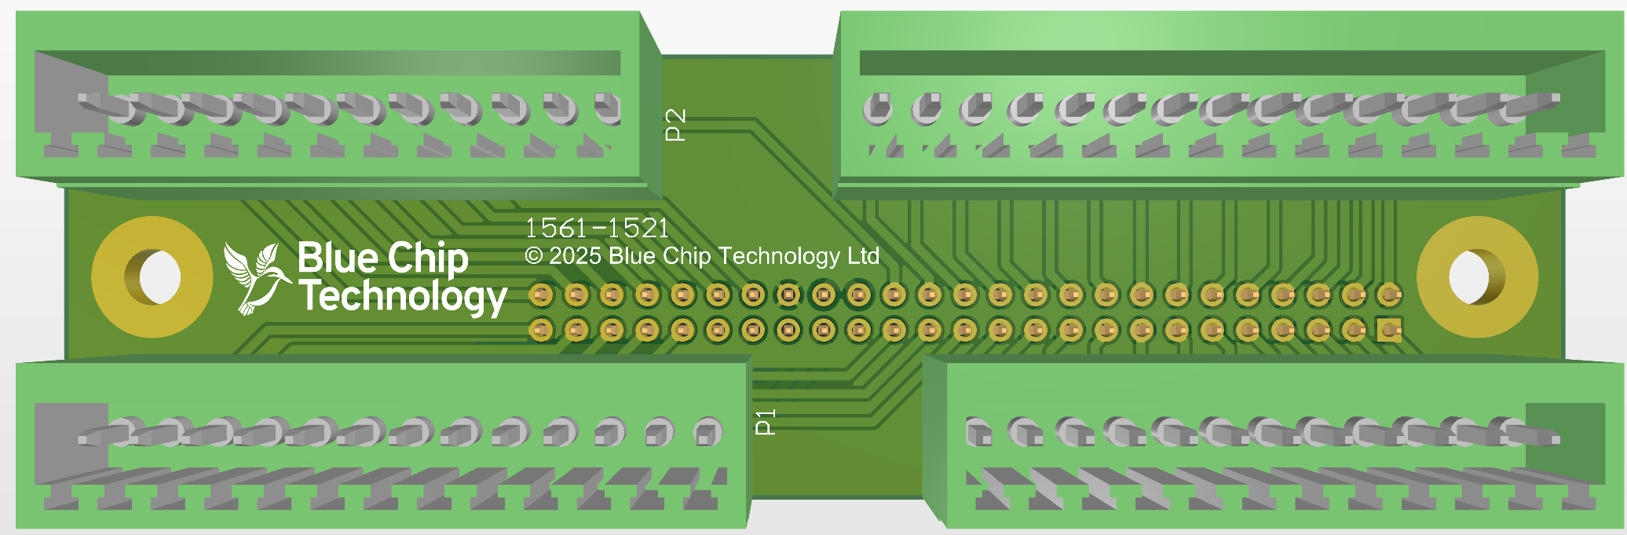
Denotes pin 1 on each connector
P1 – – RS232 & RS232/422/485
Pin | Signal | Comment
P1.1 | 0 volts
P1.2 | COM2_TX | RS232 Port 2 Transmit – RS232 level
P1.3 | COM2_RX | RS232 Port 2 Receive – RS232 level
P1.4 | 0 volts
P1.5 | CTX3_P | COM Port 3 Transmit – Positive /
P1.5 | CTX3_P | COM 3 RS232 Transmit – 3volts level for RS422/485, RS232 levels for RS232
P1.6 | CTX3_N | COM Port 3 Transmit – Negative /
P1.6 | CTX3_N | COM 3 RS232 Receive – 3volts level for RS422/485, RS232 levels for RS232
P1.7 | CRX3_P | COM Port 3 Receive – Positive – 3volts level for RS422/485 /
P1.7 | CRX3_P | COM Port 3 RS232 Receive – RS232 levels for RS232
P1.8 | CRX3_N | COM Port 3 Transmit – Negative /
P1.8 | CRX3_N | COM 3 RS232 Receive – 3volts level for RS422/485, RS232 levels for RS232
P1.9 | 0 volts
P1.10 | SCL | I²C Clock at a 3 volts level
P1.11 | SCK | I²C Data at a 3 volts level
P1.12 | 0 volts
P1.13 |  | Not connected
P2
Pin | Signal | Comment
P2.1 | EXP_VBUS | USB 5 Volts
P2.2 | USB_0_P | USB +ve
P2.3 | USB_0_N | USB -ve
P2.4 | 0 volts
P2.5 | PWR_OFF# | Apply logic low to power down the unit
P2.6 | RESET# | Apply logic low to reset the unit
P2.7 | SLEEP S3# | Enter S3 mode
P2.8 | SPARE
P2.9 | 0 volts
P2.10 | VCC | 3.3 volts
P2.11 |  | Not connected
P4 - GPIO
Pin | Signal | Comment
P4.1 | 0 volts
P4.2 | GPIO12 | GPIO signal - 3.3 Volt
P4.3 | GPIO11 | GPIO signal - 3.3 Volt
P4.4 | GPIO10 | GPIO signal - 3.3 Volt
P4.5 | GPIO9 | GPIO signal - 3.3 Volt
P4.6 | GPIO8 | GPIO signal - 3.3 Volt
P4.7 | GPIO7 | GPIO signal - 3.3 Volt
P4.8 | GPIO6 | GPIO signal - 3.3 Volt
P4.9 | GPIO5 | GPIO signal - 3.3 Volt
P4.10 | GPIO4 | GPIO signal - 3.3 Volt
P4.11 | GPIO3 | GPIO signal - 3.3 Volt
P4.12 | GPIO2 | GPIO signal - 3.3 Volt
P4.13 | GPIO1 | GPIO signal - 3.3 Volt
P4.14 | 0 volts
P5 – Audio
Pin | Signal | Comment
P5.1 | 0 volts
P5.2 | LINEOUT_R | Audio line out – right channel
P5.3 | LINEOUT_L | Audio line out – left channel
P5.4 | 0 volts
P5.5 | LINEIN_L | Audio line in – left channel
P5.6 | LINEIN_R | Audio line in – right channel
P5.7 | GND
P5.8 | SPEAKER_P | Audio speaker output – Positive
P5.9 | SPEAKER_N | Audio speaker output – Negative
P5.10 | 0 volts
P5.11 | COM1_TX | RS232 Port 1 Transmit – RS232 level
P5.12 | COM1_RX | RS232 Port 1 Receive – RS232 level

Molex Picoblade
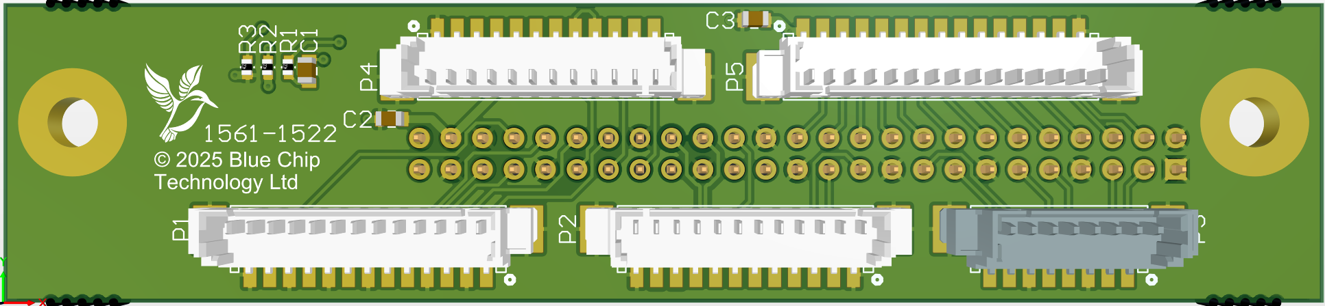
Denotes pin 1 on each connector
P1 - Utilities
Pin | Signal | Comment
P1.1 | PWR_OFF# | Apply logic low to power down the unit
P1.2 | 0 volts
P1.3 | RESET# | Apply logic low to reset the unit
P1.4 | 0 volts
P1.5 | SCL | I²C Clock at a 3 volts level
P1.6 | SDA | I²C Data at a 3 volts level
P1.7 | 0 volts
P1.8 | SLEEP S3# | Enter S3 mode
P1.9 | 0 volts
P1.10 |  | Not connected
P1.11 | 0 volts
P1.12 | SPARE
P1.13 | 0 volts
P2 – Serial COM1
Pin | Signal | Comment
P2.1 | 0 volts
P2.2 | COM1_RX | RS232 Port 1 Receive – RS232 level
P2.3 | COM1_TX | RS232 Port 1 Transmit – RS232 level
P2.4 |  | Not connected
P2.5 |  | Not connected
P2.6 |  | Not connected
P2.7 |  | Not connected
P2.8 |  | Not connected
P2.9 | EXP_VBUS | USB 5 Volts
P2.10 | USB_0_P | USB +ve
P2.11 | USB_0_N | USB -ve
P2.12 | 0 volts
P3 - Audio
Pin | Signal | Comment
P3.1 | LINEOUT_R | Audio line out – right channel
P3.2 | LINEOUT_L | Audio line out – left channel
P3.3 | 0 volts
P3.4 | LINEIN_L | Audio line in – left channel
P3.5 | LINEIN_R | Audio line in – right channel
P3.6 | 0 volts
P3.7 | SPEAKER_L | Audio speaker output – Negative
P3.8 | SPEAKER_H | Audio speaker output – Positive
P4 – RS232 & RS232/422/485
Pin | Signal | Comment
P4.1 | 0 volts
P4.2 | COM2_RX | RS232 Port 2 Receive – RS232 level
P4.3 | COM2_TX | RS232 Port 2 Transmit – RS232 level
P4.4 | VCC | 3.3 volts
P4.5 | TERM_L | 10KΩ to 0 volts
P4.6 | TERM_H | 10KΩ to 3.3 volts
P4.7 | TERM_S | Signal termination. 120Ω and 100nF in series and then P4.10 (CRX3_P)
P4.8 | CRX3_N | Connected to P4.9
P4.9 | CRX3_N | COM Port 3 Transmit – Negative /
P4.9 | CRX3_N | COM 3 RS232 Receive – 3volts level for RS422/485, RS232 levels for RS232
P4.10 | CRX3_P | COM Port 3 Receive – Positive – 3volts level for RS422/485 /
P4.10 | CRX3_P | COM Port 3 RS232 Receive – RS232 levels for RS232
P4.11 | CTX3_N | COM Port 3 Transmit – Negative /
P4.11 | CTX3_N | COM 3 RS232 Receive – 3volts level for RS422/485, RS232 levels for RS232
P4.12 | CTX3_P | COM Port 3 Transmit – Positive /
P4.12 | CTX3_P | COM 3 RS232 Transmit – 3volts level for RS422/485, RS232 levels for RS232
To clarify the entries in the table above, a part of the schematic is shown below.
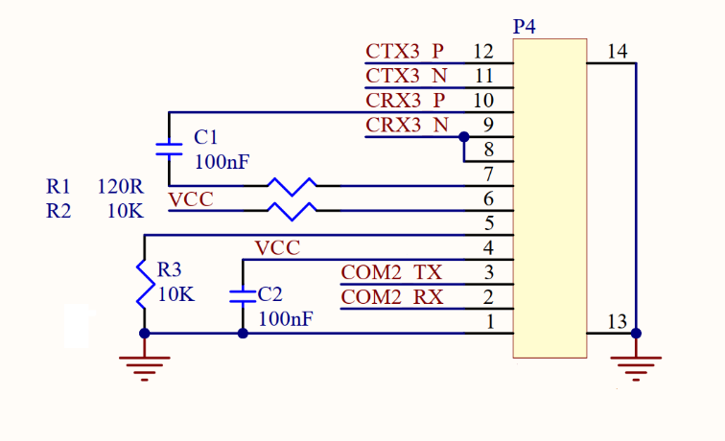
P5 - GPIO
Pin | Signal | Comment
P5.1 | VCC | 3.3 volts
P5.2 | GPIO 1 | GPIO signal - 3.3 Volt
P5.3 | GPIO 2 | GPIO signal - 3.3 Volt
P5.4 | GPIO 3 | GPIO signal - 3.3 Volt
P5.5 | GPIO 4 | GPIO signal - 3.3 Volt
P5.6 | GPIO 5 | GPIO signal - 3.3 Volt
P5.7 | GPIO 6 | GPIO signal - 3.3 Volt
P5.8 | GPIO 7 | GPIO signal - 3.3 Volt
P5.9 | GPIO 8 | GPIO signal - 3.3 Volt
P5.10 | GPIO 9 | GPIO signal - 3.3 Volt
P5.11 | GPIO 10 | GPIO signal - 3.3 Volt
P5.12 | GPIO 11 | GPIO signal - 3.3 Volt
P5.13 | GPIO 12 | GPIO signal - 3.3 Volt
P5.14 |  | Not connected
P5.15 | 0 volts

USB2.0 4 Port Hub
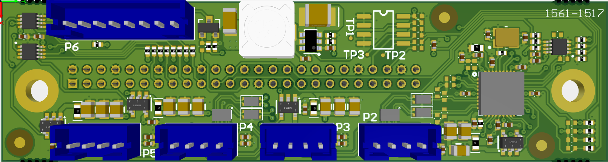
Denotes pin 1 on each connector
This expansion PCB provides four USB2.0 ports on connectors P2-P5. The user has control of the USB power for each of the ports individually using GPIOs available on the expansion connector. Note that the USB connectors used here are a non-standard USB connector. The manufacturer’s stock code for the connector used on the board is JST B4B-PH-K-S(LF)(SN).
P2-P5 Pinout
Pin | Signal | Comment
1 | VCC | USB Power 5v
2 | DATA- | USB2.0 differential data -
3 | DATA+ | USB2.0 differential data +
4 | GND | Power ground
The connector P6 is of type JST B8B-PH-K-S(LF)(SN) and provides the sleep, reset and power signals. Pins 7-8 allow a LED to be connected which indicate that the XE2 is not in a sleep state.
P6 Pinout
Pin | Signal | Comment
1 | SLEEP_BUTTON | Active low
2 | GND
3 | RESET_BUTTON | Active low
4 | GND
5 | POWER_BUTTON | Active low
6 | GND
7 | R330 | 3.3v via a 330Ω resistor
8 | POWER_ON# | Open Drain

RS422 & RS485 Operation
RS422 is a four-wire interface and supports full duplex (both transmit and receive active at the same time) communications.
RS485 is a two-wire interface and therefore supports half duplex operation. Therefore, you need to connect the Transmit +ve and Receive +ve signals together and the Transmit –ve and Receive –ve signals together to thereby create the two-wire interface required to connect to RS485 devices.
RS485 requires one device on the network to be the master and to set the protocol.
Remember that by connecting the Transmit and Receive differential pairs together (as above) then when you transmit you will effectively place the transmit data into your receive buffer! So, you need to ensure that you discard this data before you look for data in your receive buffer.
RS422 RS485
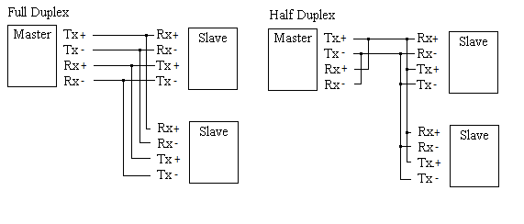
The XE2 is designed with the RS422/RS485 line driver receiver permanently enabled. The RS422/RS485 transmitter is controllable by the user. This is exposed as a GPIO and is accessed in an identical way to the other GPIOs which are available on the 50-way expansion connector. Please refer to sample C# GPIO application for a full example of using the GPIOs on the XE2. The general method is shown in the C# code sample below

using Windows.Devices.Gpio;
…
const int TX_EN_GPIO = 12; /* The TX enable pin is at index 12 */
var controller = GpioController.GetDefault();
GpioPin txEnable = controller.OpenPin(TX_EN_GPIO);
txEnable.SetDriveMode(GpioPinDriveMode.Output);
txEnable.Write(GpioPinValue.High); /* Enable the RS422/RS485 transmitter */
/*
* Write some data to the RS422/RS485 port
*/
txEnable.Write(GpioPinValue.Low); /* Disable the RS422/RS485 transmitter */
…

BIOS
The XE2 BIOS is accessed by pressing F2 when the Blue Chip Technology splash screen is displayed.
The BIOS used on XE2 is an implementation of UEFI (Unified Extensible Firmware Interface). UEFI is a modern replacement for the traditional PC BIOS, offering support for larger drives, and advanced security features and a new disk partitioning scheme to replace the master boot record scheme created by IBM many years ago. UEFI is maintained by a consortium of manufacturers, and the specification is available here
https://uefi.org/specs/UEFI/2.10/01_Introduction.html
It should be noted that the XE2 does not support the booting from non-GPT partitioned disks which is not a requirement of the UEFI specification. The means that legacy operating systems such as DOS cannot be used with XE2.

Secure Boot
Secure Boot is a UEFI feature that ensures that the XE2 will only start with trusted, digitally signed software, preventing malware from hijacking the boot process. It’s a cornerstone of modern system security and is required for non-LTSC versions of Windows 11. Users of Windows 11 LTSC are left with the choice of whether to use secure boot or not. It works by requiring the bootloader and all drivers to be signed by a trusted authority. Each stage of the boot process verified that next is using signed code and thus only trusted code is allowed to execute as the operating system loads.
To enable/disable secure booting, press F2 and choose the “Device Manager” in the main BIOS screen. In the next screen select “Secure Boot Configuration” followed by “Attempt Secure Boot”. Press the spacebar to select or deselect the option. Press F10 to save the configuration.

Boot Order
It is possible to change the XE2 boot order. To do this select the “Boot Maintenance Manager” option from the main BIOS screen followed by “Boot Options” and finally “Change Boot Order”. A list of boot device is then displayed. Press the Return key and use the up and down arrow keys to select and the ‘+’ or ‘-‘ keys on the numeric keypad to change order of the items. To set the new boot order, press the Return key and F10 to save the new settings.

BIOS Firmware upgrade via OTA
The XE2 supports OTA (over-the-air) BIOS Firmware upgrade if Windows 11 is used.
It is possible to perform a manual update to the BIOS firmware using a suitable firmware file supplied by Blue Chip Technology.
The requirements for OTA update are listed below:
- XE2 board with BIOS Firmware version 0.11 or newer.
- Windows 11 installed with the default partition layout: the first partition of the boot drive (eMMC or SSD) is the “invisible” UEFI partition of at least 100MBytes of size and formatted with the FAT file system. Other partitioning options are supported as well: first partition on non-bootable drive –either eMMC, m.2 SSD or USB disk.
- A digitally signed BIOS image, typically named “FwuImage.bin” is available from Blue Chip Technology. This file contains the BIOS FW upgrade for XE2 board. The typical size of the file is 16 Mbytes. Blue Chip Technology sales department can advise whether an upgrade is available. Please send the serial number of the XE2 board along with the current version of the XE2 board firmware as found in ‘msinfo32’ Windows application.
- For testing and development purposes Blue Chip Technology can provide test firmware images which may be used to test the whole upgrade process. The test upgrade image won’t contain any security or other improvements; it will differ only in the released version string as a bare minimum to verify the upgrade process finished as expected.
- A secure delivery process that retrieves the “FwuImage.bin” from trusted storage and saves it as a local file on the XE2. Typically, the file can be downloaded from a HTTPS server over the Internet or private LAN. The secure delivery of the “FwuImage.bin” file is beyond the scope of this document. It is assumed the file is available on the XE2 local file system.
The steps to upgrade the BIOS FW are listed below. Please note that they require Administrator privileges.
- Mount the UEFI partition as the B: drive. Required only if you use the Windows boot disk drive for performing the update.
mountvol b: /s
- Copy the “FwuImage.bin” to the root of the B: drive and verify its integrity. Overwrite an existing instance of the file, if it already exists. If you are not using Windows boot disk drive, then copy the “FwuImage.bin” to the root of the 1st partition on eMMC, m.2 SSD or USB disk. Note that the 1st partition must be FAT32 formatted.
- Unmount the B: drive. Required only if you use the Windows boot disk drive for performing the FW Upgrade (ie. if the step 1 was done).
mountvol b: /d
- If BitLocker is being used on the Windows boot drive, then suspend it, so that it won’t ask the Recovery key on the next boot. This is done by issuing the following command:
manage-bde -protectors -disable C:
- Create a visual basic script named “fwu.vbs” using the text below that triggers the FW upgrade on the next reboot.
Set Service = GetObject("winmgmts:root/wmi")
Set EnumSet = Service.InstancesOf ("AcpiFirmwareCommunication")
For each instance in EnumSet
instance.Command = 1
instance.Put_()
next 'instance
- Run the fwu.vbs file by issuing the following command:
cscript fwu.vbs
- Reboot the XE2 board. Issue the following command to reboot XE2 board:
shutdown -r -f -t 0
- During the reboot, the BIOS FW upgrade takes place. There are 2 stages involved in the upgrade:
- The first stage writes the firmware to the primary section of the SPI flash.
- The second stage writes the firmware to the backup section of the SPI flash.
- and the board will automatically reboot between the upgrade stages.
After both BIOS FW upgrade stages are completed, the board resets itself and the Windows OS is started. When using BitLocker ensure all USB disks are unplugged from the XE2 USB port at the very end of the upgrade. Failure to do this, may result in the need to enter the BitLocker recovery key. If a USB disk is detected at the very end of the upgrade procedure, then the user is prompted to unplug the USB disk. If the USB disk is left in the USB slot for longer than 3 minutes the upgrade procedure finishes the upgrade, however the BitLocker consequences apply.
When using BitLocker, the protection of the boot drive will be automatically resumed within 2 to 3 minutes after the start of the OS. It is possible to monitor the BitLocker status of the boot drive by issuing the following command:
manage-bde-status C:
Wait for the BitLocker to be resumed and for the boot drive to be fully protected.
- Verify the BIOS version matches the new upgraded version by issuing the following command in PowerShell to obtain the BIOS version:
Get-CimInstance Win32_BIOS | findstr /C:”BIOSVersion”
- Reboot the board so that all new BIOS features are applied. This is required for peripheral updates defined in ACPI tables, which are recognised by Windows only in the subsequent boot after the ACPI tables were changed. Issue the following command to reboot the XE2.
shutdown -r -f -t 0
After the reboot, Windows is ready for normal operation with the updated BIOS firmware.
The XE2 BIOS Firmware has a Resiliency feature built in. It ensures that when an error happens during firmware upgrade then a backup version of the BIOS Firmware is used to boot the XE2 board and keep it operational.

BIOS Firmware upgrade via USB Drive
The XE2 BIOS FW can be updated from a USB drive
The requirements for a USB drive update are listed below:
- XE2 board with BIOS Firmware version 0.10 or newer.
- A digitally signed BIOS image, typically named “FwuImage.bin” is available from Blue Chip Technology. This file contains the BIOS FW upgrade for XE2 board. The typical size of the file is 16 Mbytes. Blue Chip Technology sales department can advise whether an upgrade is available. Please send the serial number of the XE2 board along with the current version of the XE2 board firmware as found in ‘msinfo32’ Windows application.
The steps to upgrade the BIOS FW are listed below.
- Copy “FwuImage.bin” to a FAT32 formatted USB drive.
- Insert the USB drive into any available socket on the XE2.
- Start the XE2 and enter BIOS setup when prompted by pressing ‘F2’.
- Select the “Boot Maintenance Manager” option and then “Firmware Update”.
- Optionally, it is possible to check the BIOS FW version of the file on the USB drive using the “Check firmware update version” menu option.
- Select “Start firmware update” to begin the BIOS FW update.
- The process completes automatically with the XE2 restarting twice. Remove the USB drive when instructed.

General Precautions
Your Beta H series Touch Computer is susceptible to damage by electrostatic discharges. To avoid damage, you should work at an anti-static bench and observe normal anti-static precautions. Wear an anti-static wrist strap connected to an earth point before opening any packaging.
Where a wrist strap is not available, discharge any static charge you may have built-up by touching an earth point. Avoid any further movement that could build up another static charge. Touch an earth point from time to time to avoid further build-up, and remove the items from their anti-static bags only when required
To avoid potential irreparable damage to the XE2 the 50-way expansion board must be aligned correctly with the mating connector prior to fitment, and the power must be off.
Always make sure that the two locating screws are fitted before power is applied. Any damage caused by user misalignment will invalidate the warranty on this product.

Electro-Static Discharges
It is important to realise that the devices on the XE2 within this unit can be damaged by static electricity. Bear in mind that the damage caused by static electricity may vary from partial damage to total destruction. In the case of partial damage, this may not be immediately obvious and will have an effect on the product's reliability and warranty. Before doing any work which will bring you into contact with the XE2, ensure that you take necessary static precautions. Ideally you should work at an anti-static bench and wear an approved wrist strap or if that is not possible, touch a suitable ground to discharge any static build up before touching the electronics. This should be repeated if handling the XE2 continues for any length of time.
If it is necessary to remove a board or electronic assembly, place it into an anti-static bag. This will prevent any static electricity build up damaging the board. Metallised bags are preferred. Do not use black anti-static bags for any item containing a battery because these tend to be conductive and will discharge the battery.

Electromagnetic Compatibility
This product has been assessed operating in representative, standard configurations. As with any computer product, however, final installation & configuration can vary significantly, and so the following guidelines are offered to help ensure that compatibility is maintained.
- All components added to a system should either carry appropriate equivalent levels of compliance or be tested for compliance as part of the final system, and should be installed in accordance with supplier recommendations.
- The external enclosure should be securely fastened (with standard lids and covers in place) to ensure good metal-to-metal contact around the internal electronics
- Any metal back plate must be securely screwed to the chassis of the computer to ensure good metal-to-metal (i.e. earth) contact.
- Any metal, screened, connector bodies should be securely connected to the enclosure.
- The external cabling to boards causes most EMC problems. It is recommended that any external cabling to the board be totally screened, and that the screen of the cable connects to the metal end bracket of the board or the enclosure and hence to earth. Round, screened cables with a braided wire screen are used in preference to those with a foil screen and drain wire. Wherever possible, use metal connector shells that connect around the full circumference of the cable screen: they are far superior to those that earth the screen by a simple “pig-tail”.
- If used, a keyboard or mouse will play an important part in the compatibility of the processor card since they are ports into the board. Similarly, they will affect the compatibility of the complete system. Fully compatible peripherals must be used otherwise the complete system could be degraded. They may radiate or behave as if keys/buttons are pressed when subject to interference. Under these circumstances it may be beneficial to add a ferrite clamp on the leads as close as possible to the connector. A suitable type is the Chomerics type H8FE-1004-AS.
- USB cables should be high quality screened types.
- Ensure that the screens of any external cables are bonded to a good RF earth at the remote end of the cable.
Failure to observe these recommendations may invalidate the EMC compliance

On-Board Battery
The processor board Real time Clock can be fed from an external Lithium battery. Great care should be taken with this type of battery. If the battery is mistreated in any way there is a very real possibility of fire, explosion, and personal harm. Under NO circumstances should it be short-circuited, exposed to temperatures more than 100°C or burnt, immersed in water, recharged or disassembled.
Expired batteries remain hazardous and must be disposed of in a safe manner, according to local regulations.
Le panneau de processeur est équipé d’une batterie de lithium. Le grand soin devrait être pris avec ce type de batterie. Si la batterie est mistreated il y a de dans de toute façon un possibility très vrai du feu, d’expolosion et de mal personnel. Dans au cunes circonstances il est sous peu circuité, exposé aux températures au dessus de 100 degrés de centrigrade ou brûlé, immergé dans l’eau, rechargée ou dissassambled.
Les batteries expirées restent dazaedous et doivent être reejetées d’une façon sûre, selon des règlements locaux.

On-Board EMMC
The on-board EMMC used in your XE2 uses flash memory to provide non-volatile storage with rapid data access and mechanical resilience. However, a significant drawback of this type of memory is its inherently limited operational lifetime. It is important that this is considered for your particular use case.
The most significant factor limiting the lifetime of flash memory is the process of writing and erasing data, which is measured in program/erase (P/E) cycles. Each cycle subjects the cell’s insulating oxide layer to electrical stress, gradually degrading its integrity over time. As P/E cycles accumulate, the insulating material within each memory cell experiences wear, diminishing its capacity to reliably store electrical charges. This degradation manifests as:
- Data retention issues: The cell may lose the ability to accurately preserve data over time.
- Write errors: Programming new data may become unreliable.
- Read disturbances: The act of reading data can inadvertently alter adjacent memory cells.
When the degree of wear exceeds acceptable thresholds, affected memory cells are retired by the controller, and data is redirected to available spare cells. Once all reserves are depleted, the storage device’s capacity and reliability decline. Manufacturers implement various techniques to extend flash memory lifespan, including wear levelling (distributing write and erase cycles uniformly across cells), error correction codes (ECC), and overprovisioning (reserving spare cells for future use). Despite these measures, the physical limitations of flash memory cannot be entirely overcome.
There are several flash memory technologies currently available. The on-board EMMC uses a combination of two of these which have differing lifespans:
- SLC (Single-Level Cell): Stores one bit per cell; endures approximately 30,000–100,000 P/E cycles.
- MLC (Multi-Level Cell): Stores two bits per cell; typically supports 3,000–10,000 P/E cycles.
The way in which the different cell types are used is handled by the EMMC device using the built-in wear-levelling algorithm and cannot be altered by the user.
The XE2 BIOS provides wear information for the on-board EMMC which are obtained from the EMMC device itself. This can be seen by pressing F2 when the splash screen is displayed.
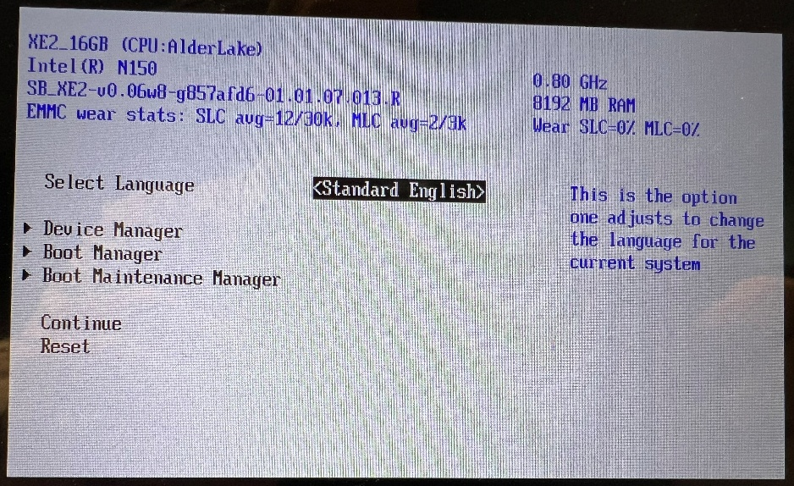
The wear statistics are shown in two ways:
- As a fraction of the P/E cycles individually for SLC and MLC. The image above shows 12 out of a total 30,000 P/E cycles completed and 2 out a total of 3,000 P/E cycles completed.
- The same fractions expressed as percentages.
Customers planning to use the EMMC for their application are recommended to use the information provided by the BIOS to estimate the lifetime of the EMMC. This is done running the application under typical operating conditions to provide a change the BIOS wear statistics. From this, it is possible to estimate the time for the SLC and MLC averages to reach their maximum values of 30,000 and 3,000 respectively.
To improve the EMMC lifetime, consider the following:
- Minimise or eliminate log file writing.
- Ensure that there is no debugging information being written to the EMMC.
- Depending on the applications memory requirements, it might be possible to disable the pagefile.
- Consider using an M.2 SSD. The greater storage capacity leads to increased lifetime.

Windows 11 IOT Enterprise LTSC
The version of Windows 11 supported with XE2 is Windows 11 IOT Enterprise LTSC. LTSC stands for Long-term Servicing Channel, which essentially means the operating system is supported by Microsoft for a much longer life cycle than mainstream versions of Windows 11. While mainstream versions of Windows 11 will receive a major update every 12 months, LTSC branches will remain stable for 10 years from release. Microsoft still supports the operating system in the form of bug fixes and security updates but does not include feature enhancements. We think this stability is important for embedded applications.
After installing Windows 11 LTSC, there are usually drivers which are not found by Windows Update. To simplify the initial setup for users wishing to create their own Windows images an XE2 driver -pack is available on the BCT website at the following URL.
https://downloads.bluechiptechnology.com/xe2/Software/xe2-driver-pack-260114.zip
Note: The zip file is approximately 3GB.

Peripherals

Serial Ports
The XE2 serial ports are mapped as follows.
Hardware Signals | Windows Port
COM1_TX, COM1_RX | COM1
COM2_TX, COM2_RX | COM2
CTX3_P, CTX3_N, CRX3_P, CRX3_N | COM3

Audio Playback
The XE2 audio outputs are mapped as follows.
Hardware Signals | Windows Playback Device
SPEAKER_H, SPEAKER_L | Speakers
LINEOUT_R, LINEOUT_L | Headphones

GPIO and I2C Bus Drivers
Accessing the GPIO and I2C Bus of the XE2 under Windows requires suitable drivers to be loaded. These are the Intel GPIO Host Controller and the Serial IO Drivers. The presence of these can be determined by expanding the “System Device” node in Windows Device Manager.
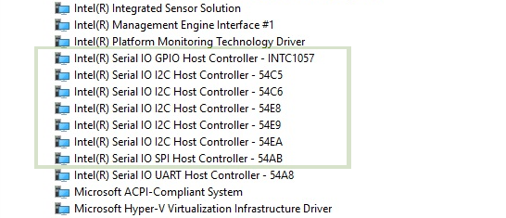
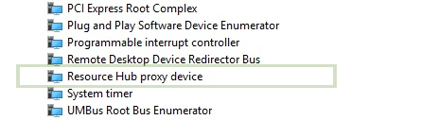

GPIO sample
An example C# GPIO application is included in this zip file.
https://downloads.bluechiptechnology.com/xe2/Software/xe2-demo.zip
Up to 12 GPIOs can be used on the XE2. The GPIO pin numbers on the P15 pin header are 25, 23, 21,19, 17, 15, 13, 11, 9, 7, 5, 3 for GPIOs 1 to 12 respectively. Please note that the example program uses zero based GPIO index and therefore GPIO1 has index 0, GPIO2 has index 1 etc. All pins operate at 3.3V and are not 5V tolerant. GPIO direction can be set either for Output or Input and Input has an option for weak pull up or pull down. The default state of the GPIOs after the OS boot is Input with weak pull down.
The GPIO pin access is implemented in C# by using ‘Windows.Devices.Gpio’ API. The process of controlling a GPIO pin involves these steps:
- Getting the GpioController object
- Creating GpioPinDriveMode object which defines the direction of the pin: Input / Output, and possibly also the Pull Up / Down Input option.
- Getting the GpioPin object from GpioController via OpenPin(pinNumber) method and passing the GPIO pin zero based index number.
- Setting the drive mode on the GpioPin object via SetDriveMode method.
- Issuing Write() on the GpioPin with the desired output value.
- Issuing Read() on the GpioPin to get the actual GPIO Pin value. An input value change callback method can be registered on a GpioPin object by setting its ValueChanged property.
The example shows how to set the output value on a specific pin or how to read a value from specific pin. The example application requires 2 arguments when it is invoked. The first argument specifies the zero-based GPIO pin index number, the second argument can be either ‘0’ for setting Low output value, ‘1’ for setting High output value or ‘i’ for reading the input value.
The output of the example should be as follows (note that arguments ‘2 1’ mean the GPIO3 is set to High output):
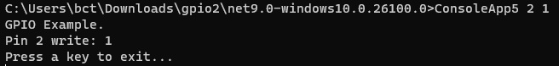

I2C Sample
An example C# I2C application is provided. Refer to the GPIO demo for the URL.
The 50-way pin header P15 exposes one I2C bus exclusively for user peripherals. The clock pin number is 44, and the data pin number is 46. See section 4 for the P15 pin layout. The XE2 board has pull up resistors of 499 Ohms installed on both pins. Low power I2C devices operating at 3.3V can be powered from pin 47 marked as V3P3A on the pin layout in section 4.
The I2C device access is implemented in C# by using ‘Windows.Devices.I2c’ API. The process of communication with an I2C device involves these steps:
- Getting the I2Controller object.
- Creating I2cConnectionSettings object and passing the I2C device address into it.
- Getting the I2cDevice from the I2Controller by passing the I2cConnectionSettings object.
- Issuing Read and Write operations upon the I2cDevice object.
The example shows how to communicate with an I2C accelerometer (MMA8452Q) and how to read accelerometer data for X Y and Z axis.
The output of the example application should be as follows:
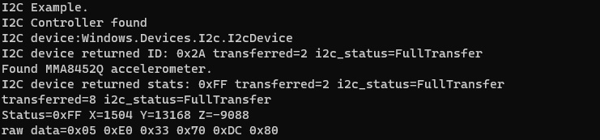

Contact Details
Blue Chip Technology Ltd.
Chowley Oak
Tattenhall
Chester
CH3 9EX
U.K.
Telephone: 44 (0)1829 772000
Website: https://bluechiptechnology.com/
Technical Support https://bluechiptechnology.com/support/online-helpdesk/
Product Returns https://bluechiptechnology.com/support/product-returns/

Amendment History
Issue Level | Issue Date | Author | Amendment Details
0.1 | 21/01/2026 | CC | Initial release

Use of the Support email address requires the sender to be first registered on the Support website.

